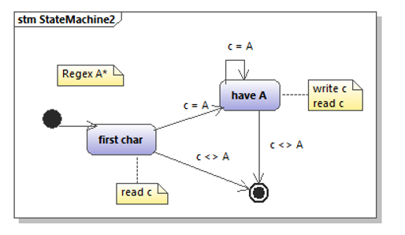

state machine version:

state = “first char”
while (state != “done”)
if (state == “first char”)
read c
if (c = A) state = “have A”
if (c <> A) state = “done”
if (state = “have A”)
write c
read c
if (c <> A) state = “done”
done

non-state machine version:

read c
while (c == A)
write c
read c

